MIAMI STATE HIGH SCHOOL
YEAR 10 GRAPHICS
Design Technology Department
Student |  | Class | GPH101A
Teacher | Mrs Wortmann | HOD | Mr Wilkinson
Due Date |  | Draft

Design Project (25%)

Assessment objectives

- Explain how products, services and environments evolve with consideration of preferred futures and the impact of emerging technologies on design decisions
- Critique needs or opportunities to develop design briefs and investigate and select an increasingly sophisticated range of materials, systems, components, tools and equipment to develop design ideas
- Develop, modify and communicate design ideas by applying design thinking, creativity, innovation and enterprise skills of increasing sophistication
- Evaluate design ideas, processes and solutions against comprehensive criteria for success recognising the need for sustainability.

Criterion | Marks  allocated | Result
Knowledge and Understanding  Assessment objective 1 | 5
Investigating and defining  Assessment objective 2 | 5
Generating and designing  Assessment objective 3 | 5
Producing and implementing  Assessment objective 3 | 5
Evaluating  Assessment objective 4 | 5
Total | 25

Feedback comments ______________________________________________________________________________________________________________________________________________________________________________________________________________________________________________________________________________________________________________________________________________________________________________________________________________________________________________________________________________________________________________________________________________________

Subject | Graphics |  | Instrument no. |  | Summative 2
Technique | Project
Unit | Unit 2: Design process
Topic | Architecture
Conditions
Time | 7 weeks in class and student’s own time | Perusal |  | Nil
Word length | See task | Seen/unseen |  | Seen
Other | - Folio submission to be submitted in a word document  - Scale model to be submitted with folio on solid base
Special Instructions
Use design templates highlighted in pink.
Context
Gold Coast City Council provides funding for public infrastructure. Architects are an integral part in this process to ensure preferred futures are considered in the development of transport for the local area. Architecture is the art of designing buildings and other structures to meet a need identified by humans. It has a social responsibility to respect the context and the purpose it is going to serve.
Task
Present a design process folio in response to the following task:
The Gold Coast City Council has approached you, as an aspiring architect, to design a new concept for a bus stop which will meet the needs of society’s preferred futures.

To complete this task, you must:
- Analyse a complex problem
- Describe needs and opportunities
- Develop a project management plan
- Develop criteria for success
- Represent design ideas and concepts
- Synthesise ideas
- Generate a final design and make a final solution (model)
- Evaluate the success of your project

Criterion: Knowledge and understanding (technologies and society)  Requirement 1  The student work has the following characteristics: Marks  Analysis and explanation of the changes necessary to designed solutions to realise preferred futures they have described 5  Analysis and description of the changes necessary to designed solutions to realise preferred futures they have described 4  Identification of the changes necessary to designed solutions to realise preferred futures they have described 3  Identification of aspects of the changes necessary to designed solutions to realise preferred futures they have described 2  Statements about the changes necessary to designed solutions to realise preferred futures 1  Does not satisfy any of the descriptors above 0 | Criterion: Processes and production skills (generating and designing)  Requirements 5 and 6  The student work has the following characteristics: Marks  - purposeful representation and synthesis of design ideas and processes of increasing complexity - discerning justification of decisions 5  - effective representation and synthesis of design ideas and processes of increasing complexity - informed justification of decisions 4  - creation and representation of design ideas and processes of increasing complexity - justification of decisions 3  - partial representation and connection of design ideas and processes - explanation of decisions 2  - fragmented representation of design ideas and processes - statement of decisions 1  Does not satisfy any of the descriptors above 0
Criterion: Processes and production skills (investigating and defining)  Requirements 2, 3, 4  The student work has the following characteristics: Marks  Description of designed solutions for one or more of the technologies contexts based on a discerning critical evaluation of needs or opportunities Proficient development of insightful criteria for success, addressing all design factors 5  Description of designed solutions for one or more of the technologies contexts based on an informed critical evaluation of needs or opportunities Effective development of criteria for success addressing all design factors 4  Description of designed solutions for one or more of the technologies contexts based on a critical evaluation of needs or opportunities Development of criteria for success for most design factors 3  Description of partial designed solutions for one or more of the technologies contexts based on a partial evaluation of needs or opportunities Partial development of criteria for success 2  Description of fragmented designed solutions for one or more of the technologies contexts based on statements about needs or opportunities Limited to no criteria developed to measure success 1  Does not satisfy any of the descriptors above 0 | Criterion: Processes and production skills (producing and implementing)  Requirements 7 and 8  The student work has the following characteristics: Marks  proficient production of high quality designed solutions suitable for the intended purpose by selecting and using appropriate technologies skilfully and safely 5  effective production of high quality designed solutions suitable for the intended purpose by selecting and using appropriate technologies skilfully and safely 4  production of high quality designed solutions suitable for the intended purpose by selecting and using appropriate technologies skilfully and safely 3  guided production of designed solutions for the intended purpose by selecting and using technologies safely 2  guided production of designed solutions for a purpose by using technologies safely 1  Does not satisfy any of the descriptors above 0
Criterion: Processes and production skills (Evaluating)
Requirement 9

The student work has the following characteristics: | Marks
- Establishment of comprehensive and detailed criteria for success, including sustainability considerations  - Use of detailed criteria to make a discerning evaluation of:  -their ideas  -designed solutions  -processes | 5
- Establishment of informed and detailed criteria for success, including sustainability considerations  - Use of detailed criteria to make an informed evaluation of:  -their ideas  -designed solutions  -processes | 4
- Establishment of detailed criteria for success, including sustainability considerations  - Use of detailed criteria to make an evaluation of:  -their ideas  -designed solutions  -processes | 3
- Establishment of criteria for success, including sustainability considerations  - Use of detailed criteria to make a partial evaluation of:  -their ideas  -designed solutions  -processes | 2
- Statements about criteria for success  - Use of detailed criteria to make a discerning evaluation of:  -their ideas  -designed solutions  -processes | 1
Does not satisfy any of the descriptors above | 0

Bus stop design
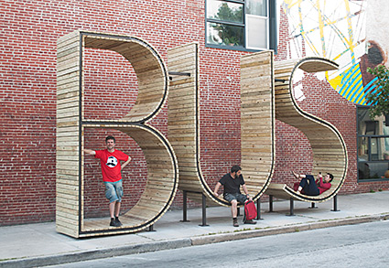

Context
Public architecture

Task
The Gold Coast City Council has approached you, as an aspiring architect, to design a new concept for a bus stop which will meet the needs of society’s preferred futures. You will need to present to them your design process as a folio to demonstrate your understanding the context along with a scale model of your design. This will also showcase your ability to successfully work through all aspects of design the design process, including divergent and convergent thinking.

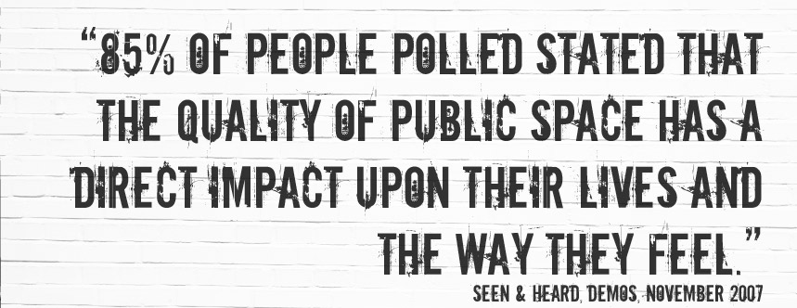

Cognitive verbs

Analyse – examine or consider something in order to explain and interpret it, for the purpose of finding meaning or relationships and identifying patterns, similarities and differences

Describe – give an account of a situation, event, pattern or process, or the characteristics or features of something

Represent – portray or depict in some sort of non-linguistic for to comprehend knowledge

Devise – think out; plan; contrive; invent

Synthesise – combine different parts or elements (e.g. information, ideas, components) into a whole, in order to create a new understanding

Evaluate – make and appraisal by weighing up or assessing strengths, implications, and limitations; make judgements about ideas, works, solutions or methods in relation to selected criteria: examine and determine the merit, value of significance of something based on criteria.

Task requirements:

Part A: Investigating and managing
- Analyse a complex problem (analytical inspiration board)
Explore a range of existing designed solutions for transport shelter and explain how:
- the solutions have evolved over time
- the designers have considered technologies, including emerging technologies e.g. materials, to develop their solutions
- competing factors (relevant design purposes) have impacted on design decisions.
- Describe needs and opportunities
Create a design brief for your initial proposed design solution. In this proposal:
- summarise the problem and why it needs solutions to be developed, address stakeholder needs and wants. Summary should be in full sentences (100-150 words) Needs and opportunities brainstorm.
- critically analyse factors that will affect the design of your solution such as social, ethical, sustainability and aesthetics using the design factors template.
- Develop a project management plan
Create a project management plan using a management tool such as a PERT or Gantt chart. Include:
- a breakdown of activities required to complete the project
- the estimated time allocation to ensure completion by the due date.
- Develop criteria for success
Develop detailed criteria for success. This will help you assess how well your design ideas, processes and solution address the design challenge, needs, sustainability considerations and other factors (social, ethical, sustainability, aesthetics). Use the criteria for success template.
Part B: Designing, producing and evaluating a solution
- Represent design ideas and concepts
Using the information you have gathered during your investigation, draw/sketch three (3) design ideas for your project portfolio. Consider the type of drawings that will best represent your idea (plan, perspective). Justify your design ideas using the PMI template.
- Synthesise design ideas
Compare the design ideas against your criteria for success. Select the most appropriate design and justify your choice using the criteria design matrix.
- Generate final design
Communicate a detailed graphical representation of your final design annotated to show how it addresses factors and combines characteristics and properties of materials and technologies. Ensure you consider the technologies to be used and the type of drawing you will present.
- Make designed solution
Construct a scaled model of your final design using appropriate prototyping materials.
Scale 1:20
- Evaluate success
Evaluate your designed solution and the processes taken to realise the product, including explaining and justifying:
- how well the product addresses the criteria for success
- improvements to the solution, including opportunities for innovation and enterprise.

