**SUCCESS CRITERIA:**

I can correctly identify the elements and principles of design used in existing ring designs

I can confidently sketch a circular and/or cylindrical object in 3D

I can portray clear design sketches using shading and rendering techniques to provide 3D imagery

I was able to produce 1-2 sketches of my design from different viewpoints

I am able to produce a consistent fusion weld with good penetration

**INSTRUCTIONS:**

Analyse the rings on the sheet provided and annotate the elements and principles of design that you can identify on each ring

Identify the features of the designs that you liked the best and explain why you do

Sketch ten design possibilities for your ring design and annotate which elements and principles you have used and the level of appeal with each design and why.

Select your favourite design and produce five rendered sketches from different points of view.

**EQUIPMENT REQUIRED:**

Ring design analysis sheet

Sketching and rendering equipment

Visual Diary

**LEARNING GOALS:**

To analyse the elements and principles of design in existing rings

To use the elements and principles of design to design a ring from a blank band using piercing as the only manufacturing technique

To develop skills in sketching 3D circular and cylindrical objects

To produce a series of 1-2 rendered sketches of the design solution

**RING DESIGN**

**FASHION DESIGN TASK 1**

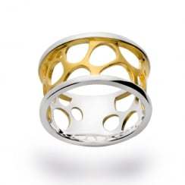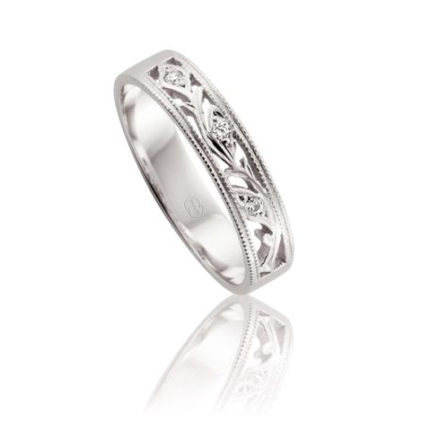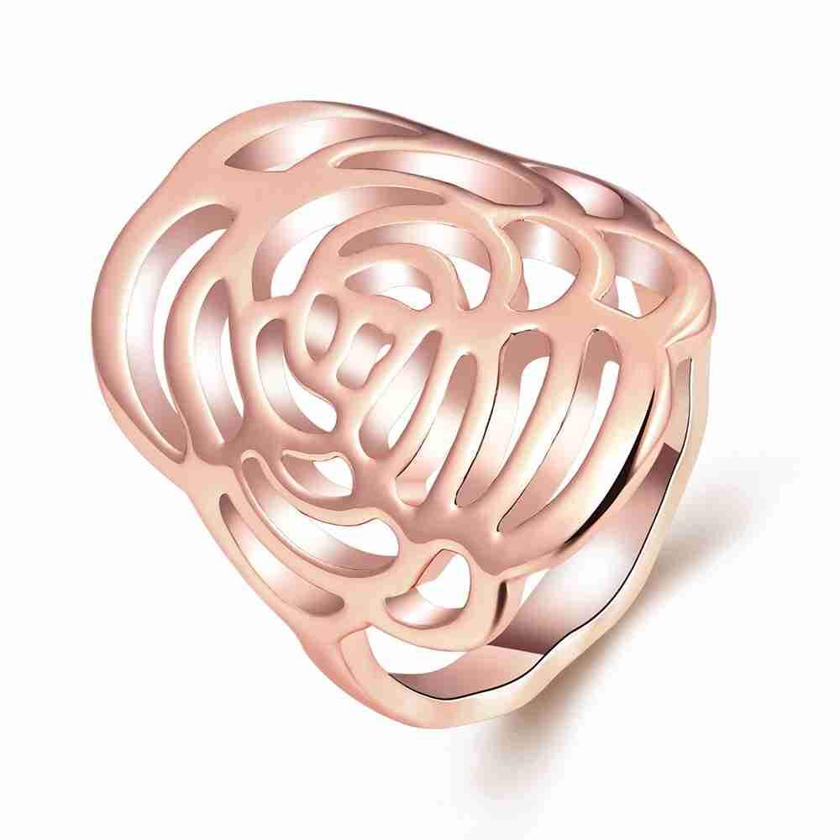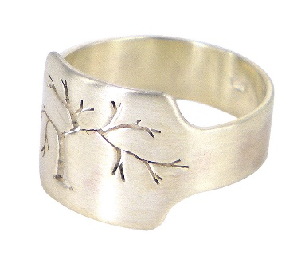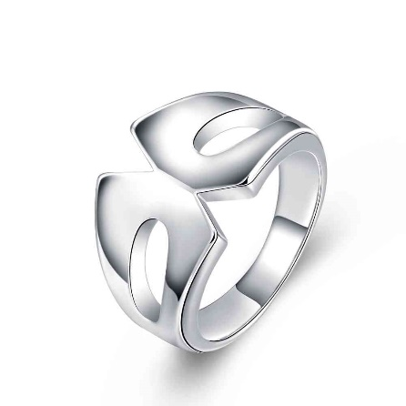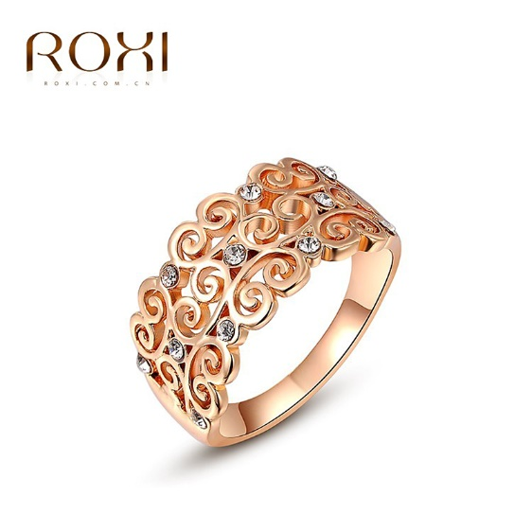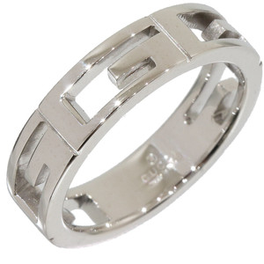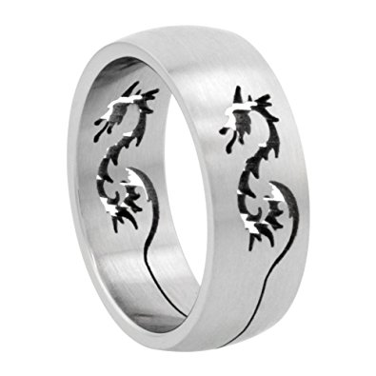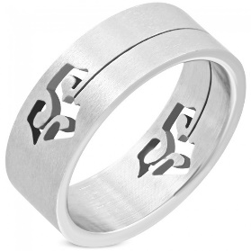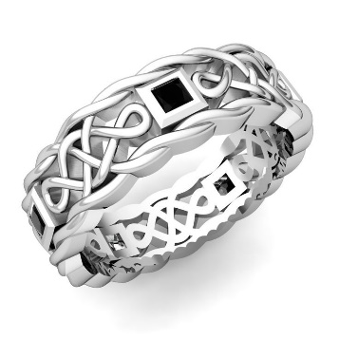

**EXISTING DESIGNS**

**FASHION DESIGN TASK 1**

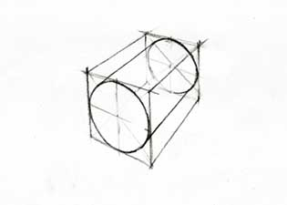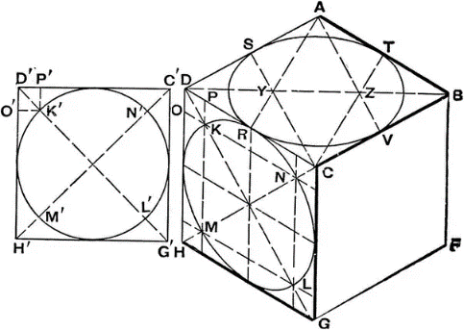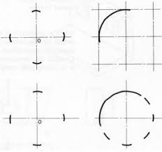

**SKETCHING 3D CIRCLE**

* **construct a square in 3D**
* **draw the centre axes**
* **draw the diagonals**
* **approximate the of K,L,M,N**
* **plot the circle**

**SKETCHING A 3D CYLINDER**

* **draw the containing box**
* **project points of reference**
* **plot the circle at the new position**
* **connect the points of tangency**

**DRAWING A 2D CIRCLE**

* **construct a square**
* **draw in the centre axes**
* **approximate the shape of a circle in one quadrant**
* **mirror the shape to the other quadrants**

**SKETCHING**

**FASHION DESIGN TASK 1**

**VISUALISATION**

**FASHION DESIGN TASK 1**

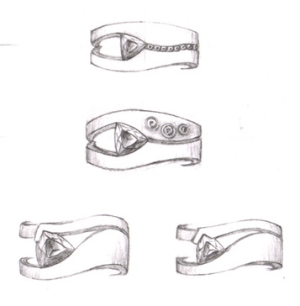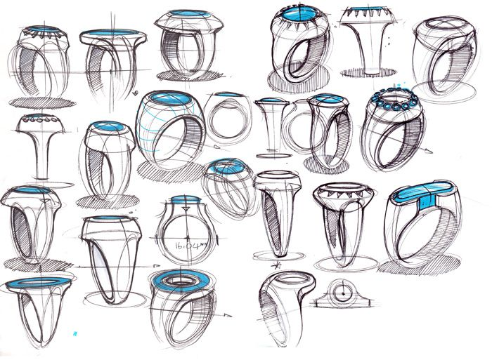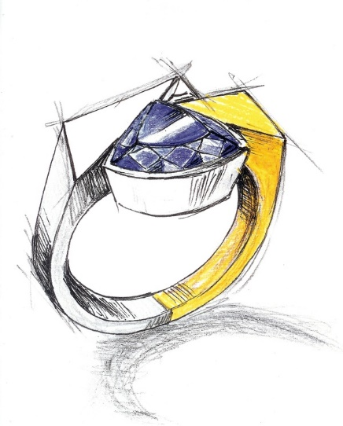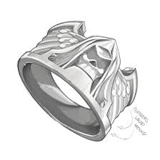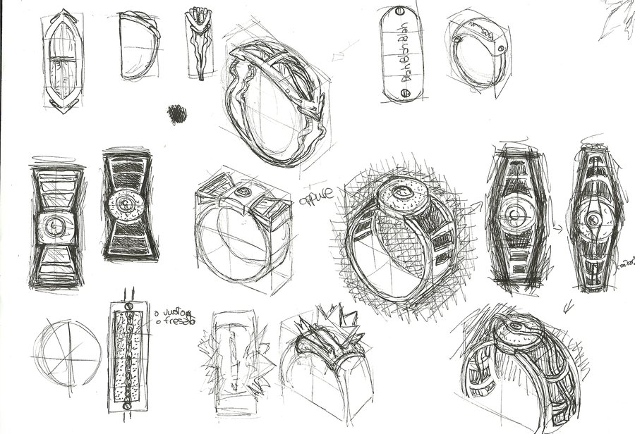

**TYPE 2 PART B – HOTS** (provide connectors, sentence starters)

Written: Select one element of design and evaluate how to use it to create emphasis in the ring designs you investigated. (93 s)

Elbow Partners: Discuss your explanations and justify why there is a preferred sequence for sketching a circle. (187 s)

**TYPE 2 QUESTIONS**

List the three (3) techniques used to create emphasis (30 s, 3 pts)

Write three (3) lines to describe useful strategies for creating ideas in response to a design task. (55 s, 6 pts)

Explain in correct order the four (4) steps you would to draw a circle in 2D. (72 s, 10 pts)

**TYPE 3 QUESTION**

In ten (10) lines, describe four (4) design criteria that you would use to evaluate ring design.

FCA 1 Four (4) design criteria identified (4 pts) UNDERLINE

FCA 2 Each sentence must start with a capital letter and end with a full stop.(4 pts) BOX

FCA 3 You must use at least three (3) different connectives in your sentences. (3 pts) CIRCLE

**TYPE 1 QUESTIONS**

List 5 of the elements of design (23 s)

List four (4) of the principles of design. (41 s)

Write a sentence to describe what you look for when analysing the work of others. (87 s)

What are the three (3) main steps used for sketching a circle in 3D. (63 s)

**COLLINS WRITING**

**FASHION DESIGN TASK 1**

**List the elements of design and describe how you would use them.**

**List the principles of design and sketch an example of each.**

**Using a pen only, neatly sketch a 2D and 3D Circle.**

**KNOWLEDGE TEST**

**FASHION DESIGN TASK 1**